**The University of New Mexico**

**School of Engineering**

**Electrical and Computer Engineering Department**

**ECE 535 Satellite Communications**

**Student Name: Alex Hostick**

Student SN: 10201139

Module # 3-2: 2.12, 2.13, 2.14, 2.16, 2.17, 2.18

Fall 2023

**Prof. Tarief Elshafiey**

**2.12 Explain what is meant by the ascending and descending nodes. In what units would these be measured, and in general, would you expect them to change with time?**

**Ascending Node**

The point where the orbit crosses the equatorial plane going from south to north. This is also the point where the body moved from being below the reference plane to being above it.

**Descending Node**

The point where the orbit crosses the equatorial plane going from north to south. This is also the point where the body transitions from being above the reference plane to being below it.

**What are the units of measurement, and would you expect them to change with time?**

The units of measurement are in hours, minutes, and seconds of time. As the book explains, because the earth spins, the orbital plane remains stationary, but the ascending node is not fixed. Due to the nodes not having a fixed point, the line of Aries, or a fixed point in space, is used. Other influences such as celestial bodies (for higher altitude satellites) and the oblateness of the earth can also change the ascending and descending nodes.

**2.13 Explain what is meant by (a) line of apsides and (b) line of nodes. Is it possible for these two lines to be coincident?**

**(a) Line of Apsides**

The line of apsides is the line joining the perigee and apogee through the center of the earth.

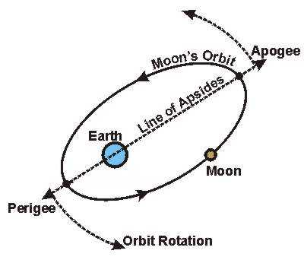

**(b) Line of Nodes**

The Line of Nodes is the line joining the ascending and descending nodes through the center of the earth.

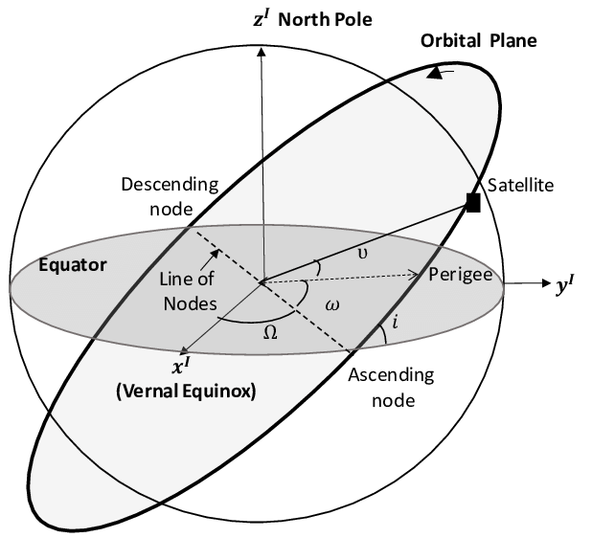

**Is it possible for these two lines to be coincident?**

Yes, it is possible for the line of apsides and the line of nodes to be coincident. Depending on the orbit, the two lines will coincide if the major axis of the elliptical orbit aligns with the line of nodes. The lines will not have coincidence if the inclination of the satellite is zero.

**2.14 With the aid of a neat sketch, explain what is meant by each of the angles: *inclination; argument of perigee; right ascension of the ascending node*. Which of these angles would you expect, in general, to change over time.**

|  |  |  |
| --- | --- | --- |
| Term | Unit | Description |
| Inclination | $$i$$ | * The angle between the orbital plane and the earth’s equatorial plane. It is measured at the ascending node from the equator to the orbit, going from east to north. It is seen that the greatest latitude, north or south, reached by the subsatellite path is equal to the inclination. |
| Argument of Perigee | ω | * The angle from the ascending node to perigee, measured in the orbital plane at the earth’s center, in the direction of satellite motion. |
| Right Ascension of the Ascending Node | Ω | * This angle defines the position of the orbit in space. The right ascension of the ascending node that is the angle measured east-ward, in the equatorial plane, from the line of Aries ($Υ$) to the ascending node (Ω) |

**Which of these angles would you expect to change over time?**

The argument of perigee and the right ascension of the ascending node may change over time. Both may change due to gravitation perturbations when the satellite is the closest to the earth. The change can also be influenced by large celestial bodies for high altitude satellite orbits.

**2.16 Describe briefly the main effects of the earth’s equatorial bulge on a satellite orbit. Given that a satellite is in a circular equatorial orbit for which the semimajor axis is equal to 42,165 km, calculate (a) the mean motion, (b) the rate of regression of the nodes, and (c) the rate of rotation of argument of perigee.**

**Earth’s Equatorial Bulge**

Earth’s equatorial bulge causes slow variations on both the argument of perigee (ω) and the right ascension of the ascending node (Ω). Also, due to the rotation of apsides line on the orbital plane, the argument of perigee changes with time. The equatorial bulge also causes rotations on the perifocal coordinate system.

Semi-major Axis (a) = 42,165 km

K1 = 66,063.1704km2

**(a) Mean Motion:**

Solve for mean motion:

$$n=\sqrt{\frac{μ}{a^{3}}}$$

$$n=\sqrt{\frac{3.986005x{10}^{14}{m^{3}}/{s^{2}}}{{(42,165x{10}^{3}m)}^{3}}}$$

$$n=\sqrt{5.329x{10}^{-9}}$$

$$n= {7.29969x10}^{-5}s^{-1}$$

**(b) Rate of Regression of the Nodes**

Find eccentricity … for circular orbit:

Semi-major Axis (a) = 42,165 km

Semi-minor Axis (a) = 42,165 km

$$e=\frac{\sqrt{a^{2}+b^{2}}}{a}$$

$$e=\frac{\sqrt{{(42,165km)}^{2}+{(42,165km)}^{2}}}{42,165km}$$

$$e=1.414$$

Then find rotation of apsides:

$$K=\frac{nK_{1}}{a^{2}{(1-e^{2})}^{2}}$$

$$K=\frac{({7.29969x10}^{-5}s^{-1})(66,063.1704{km}^{2})}{{(42,165km)}^{2}{(1-{(1.414)}^{2})}^{2}}$$

$K=\frac{2.715x{10}^{-12}rad}{sec}≈0 rad/sec$*(circular orbit)*

$$\frac{dΩ}{dt}=-(2.715x{10}^{-12}\left(cos\left(0*π/{180}\right)\right)=0 rad/sec$$

**(c) Rate of Rotation of Argument of Perigee**

Orbit is circular, thus ω ≈ 0 rad/sec

**2.17 A satellite in polar orbit has a perigee height of 600 km and an apogee height of 1,200 km. Calculate (a) the mean motion, (b) the rate of regression of the nodes, and (c) the rate of rotation of the line of apsides. The mean radius of the earth may be assumed equal to 6,371 km.**

Mean Motion: $n_{0}= \sqrt{\frac{μ}{a^{3}}}$

Rate of Regression: $K=\frac{nK_{1}}{a^{2}{(1-e^{2})}^{2}}$

$$\frac{dΩ}{dt}=-Kcos(i)$$

Line of Apsides: $\frac{dω}{dt}=K(2-2.5\sin^{2}(i)$)

Inclination (*i*) = 90° (polar orbit)

K1 = 66,063.1704km2

**(a) Mean Motion**

$$r_{a}=1200km+6371km=7571km$$

$$r_{p}=600km+6371km=6971km$$

$$a=\frac{7571km+6971km}{2}=7271km$$

$$n= \sqrt{\frac{μ}{a^{3}}}$$

$$n= \sqrt{\frac{3.986005x{10}^{14}{m^{3}}/{s^{2}}}{{(7271x{10}^{3})}^{3}}}$$

$$n=1.021x{10}^{-3}$$

$$n= \frac{1.021x{10}^{-3}}{2π}*86400\sec{≈14.05≅13.994 rev/day}$$

**(b) Rate of Regression of the Nodes:**

$$e= \frac{r_{a}}{a}-1\underset{→}{yields} \frac{7571}{7271}-1=0.41598$$

$$K=\frac{(1.021x{10}^{-3})(66,063.1704{km}^{2})}{{(7271km)}^{2}{(1-{0.041598}^{2})}^{2}}$$

$$K≈ 1.575{x10}^{-6}$$

$$\frac{dΩ}{dt}=-(1.575{x10}^{-6}\left(cos\left(90*π/{180}\right)\right)$$

$$\frac{dΩ}{dt}=0$$

**(c) Rate of Rotation of the line of Apsides**

$$\frac{dω}{dt}=K\left(2-2.5\sin^{2}\left(i\right)\right)= 1.575{x10}^{-6}\left(2-2.5\sin^{2}\left(-0.5\right)\right)$$

$$\frac{dω}{dt}= -7.555x{10}^{-7}rad/sec$$

$$-7.555x{10}^{-7}rad/\sec{*{180}/π*86400 ≈ -3.75 ≅ -3.158 deg/day }$$

**2.18 What is the fundamental unit of the universal coordinate time? Express the following times in (a) days and (b) degrees: 0h, 5min, 24s; 6h, 35min, 20s; your present time: 19h, 1min, 48s**

$${UT}_{day}=\frac{1}{24}\left(Hours+\frac{Minutes}{60}+\frac{seconds}{3600}\right)$$

$${UT}_{deg}=360°*{UT}_{day}$$

**Fundamental Unit**

The fundamental unit for universal coordinate time (UTC) is mean solar day.

**0h, 5min, 24s**

$${UT}_{day}=\frac{1}{24}\left(0hours+\frac{5min}{60}+\frac{24sec}{3600}\right)=0.00375 days$$

$${UT}_{deg}=360°*0.00375=1.35deg$$

**6h, 35min, 20s**

$${UT}_{day}=\frac{1}{24}\left(6hours+\frac{35min}{60}+\frac{20sec}{3600}\right)=0.2975 days$$

$${UT}_{deg}=360°*0.2975=107.1deg$$

**19h, 1min, 48s**

$${UT}_{day}=\frac{1}{24}\left(19hours+\frac{1min}{60}+\frac{48sec}{3600}\right)=0.7929days$$

$${UT}_{deg}=360°*0.7929=285.45deg$$